**Registration Fields**

**(use file “Path Registration” page as reference. It should look exactly like that page, but with the fields below)**

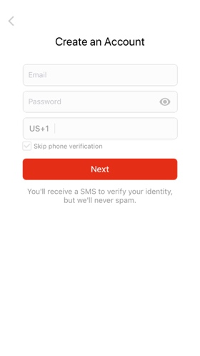

First Name

Last Name

Email

Password

Re-type Password

MLS Region (Dropdown populated with “MLS Names” in the Excel file called “List of MLS”)

MLS ID

Birthday Month, Day, Year – in this order (use library for a nice scroll)

**Login Fields**

**(use file “Login or Sign Up Page” as reference. It should look exactly like that page.)**

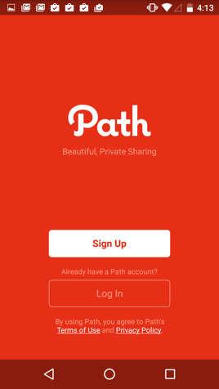

Email

Password

The output should include:

* Forgot Password button
* User should stay logged in once they have signed up / logged in
* Include HomeWise logo in the top middle instead of the Path logo (attached in project)
* Include “I have read and agree to the Terms of Service(hyperlink) and Privacy Policy (hyperlink).”
  + Don’t worry about what it links to. We will populate that later!
* We do NOT need Facebook/Google/LinkedIn integration. We will just do through email sign up
* The RGB code for the blue in our logo is R: 65 G: 147 B: 237. Make the whole screen a white background with this color for the buttons. Use this color instead of the red in the Path screenshot
* For dropdowns (birthday and MLS region), please use the nice, modern scroll that you see in the calendar app on the iPhone or in Google calendar when you’re setting a time